**Hi,  
Please Provide us following details so that we may finalize the deployment on polygon mainnet:**

**Polygon Mainnet account Private Key or Real Matics are required:**

* To deploy the smart contract on production/mainnet, we will be needing the private key of the admin’s metamask wallet which contains real matics.
* We send to you in private conversation
* Or if the admin doesn't want to share that, we will be needing some real matics to deploy the contract from our account and then give the permanent ownership to the admin’s account. Still, the admin's private key will be required as we have to allow some functions from the backend which will be needing the private key to sign the transactions.
* We choose the first option, no problem
* All the access for admin privileges will be provided to that admin/owner account ok
* Max mint count has been set to "up to 5 mints" in the contract... The admin can set any number of mints up to 5. Keep it “5”

**NFT-ES Polygon Mainnet QuickNode Endpoint:**

Please purchase us the required Endpoints for NFT-ES Project Mainnet Deployment:

Here is a complete guide how to do it:

1. Please login to Quicknode at <https://www.quicknode.com/endpoints>
2. Create Endpoint

1. Select Polygon
   1. Select Mainnet

1. For now, we are going with simple plan, but if needed we may add some ad-ons but it depends upon our needs. So,
   1. Continue

1. Select “Launch” PlanA screenshot of a computer

   Description automatically generated
2. Provide Credit card information
3. Pay and Create.
4. Please send the API Endpoint URLs.

This is the same you ask me some days ago right? These are the URLs

HTTP Provider: <https://fragrant-polished-butterfly.matic-testnet.quiknode.pro/7b6c61b170d830bf23eefef37910c64fa4303192/>

WSS Provider: wss://fragrant-polished-butterfly.matic-testnet.quiknode.pro/7b6c61b170d830bf23eefef37910c64fa4303192/

That’s OK?

**Missing Language Translations:**

**Admin side language tranlation missing**

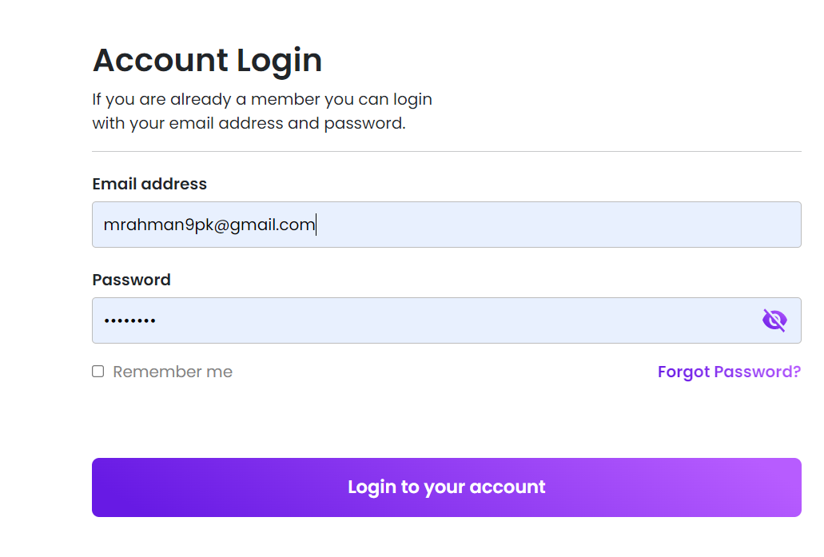

|  |  |  |
| --- | --- | --- |
| Screen | Text (English) | Text (Spanish) |
| Admin login | Account Login | Inicio de sesión |
| If you are already a member you can login with your email and password | Si ya eres miembro, puedes iniciar sesión con tu email y contraseña |
| Email Address | Email |
| Invalid email | Email incorrecto |
| Password | Contraseña |
| Wrong password | Contraseña incorrecta |
| Forgot Password | Restablecer contraseña |
| Remember me | Recordar |
| Login to your account | Iniciar sesión |
| Loading | Cargando |

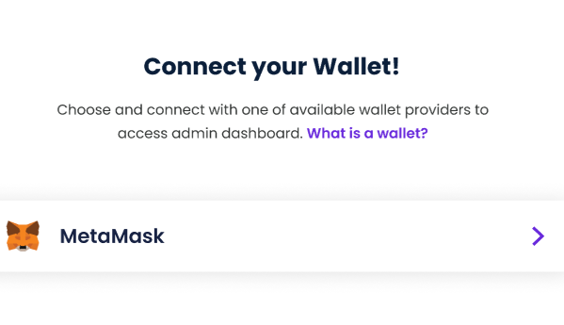

|  |  |  |
| --- | --- | --- |
| Screen | Text (English) | Text (Spanish) |
| Connect your Wallet | Connect your wallet | Conecta tu wallet |
|  | Choose and connect with one of the available wallet providers to access admin dashboard. What is wallet? | Escoge y conecta con uno de los proveedores disponibles para acceder al panel de administración. ¿Qué es una wallet? |
|  | You cannot process account without meta mask connection .found meta mask connection error | No puedes conectar tu cuenta sin una conexión con MetaMask. Enconrtar error de conexión con MetaMask |
|  | You cannot access anything with this metamask account | No puedes acceder con esta cuenta de MetaMask |

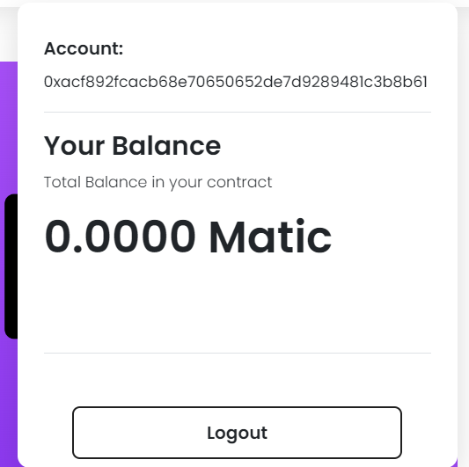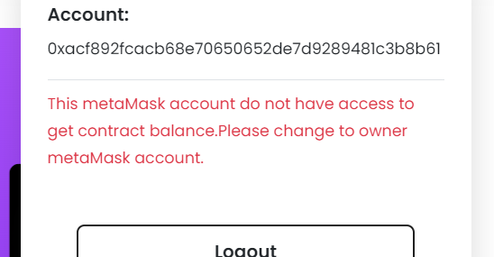

|  |  |  |
| --- | --- | --- |
| Screen | Text (English) | Text (Spanish) |
| Admin Account | Account | Cuenta |
| Your Balance | Tu saldo |
| Total Balance in your contract | Saldo total en tu contrato |
| Logout | Cerrar sesión |
|  | This meta Mask account do not have access to get contract balance . Please change to owner meta Mask account | Esta cuenta de MetaMask no tiene acceso al saldo del contrato. Por favor, cambia de cuenta Metamask. |

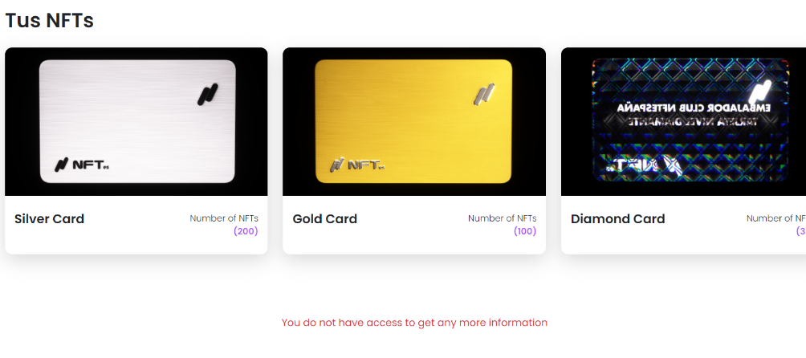

|  |  |  |
| --- | --- | --- |
| Screen | Text (English) | Text (Spanish) |
| Admin Backoffice | Number of NFTs | Número de NFTs |
|  | You do not have access to get any more information | No tienes acceso a más información |
|  | Silver | Plata |
|  | Gold | Oro |
|  | Diamond card | Diamante |

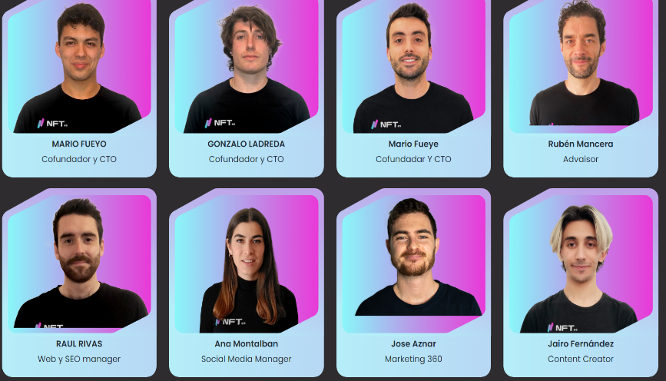

|  |  |  |
| --- | --- | --- |
| Screen | Text (English) | Text (Spanish) |
| Admin Backoffice(Team) | Advisor | Advisor |
|  | Web SEO Manager | Web SEO Manager |
|  | Social media Manager | Social media Manager |
|  | Marketing 360 | Marketing 360 |
|  | Content writer | Content writer |

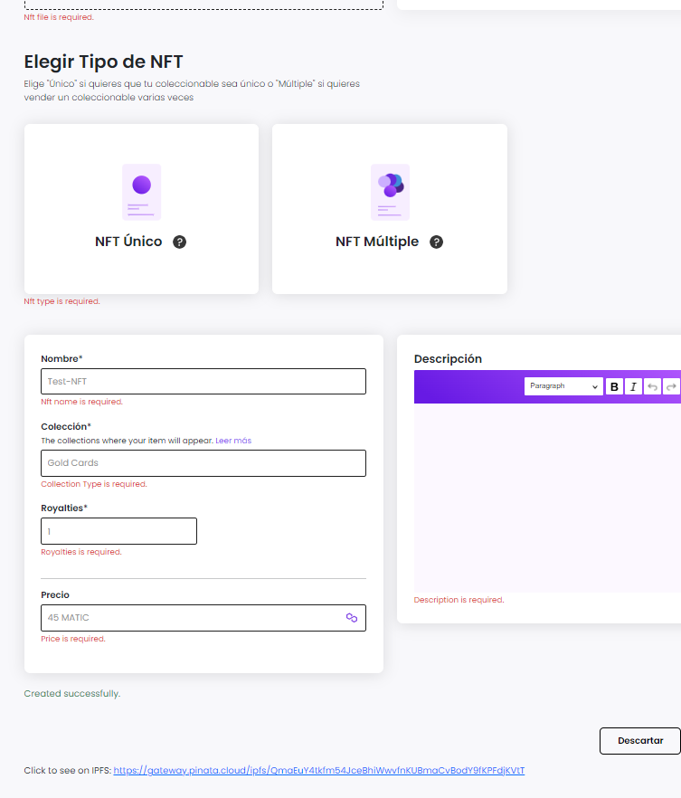

|  |  |  |
| --- | --- | --- |
| Screen | Text (English) | Text (Spanish) |
| Create NFT | NFT file is required | Se requiere un archivo NFT |
|  | NFT type is required | Se requiere un tipo de NFT |
|  | NFT name is required | Dale nombre a tu NFT |
|  | Collection Type is required | Dale nombre a tu colección |
|  | Royalties is required | Añadir royalties |
|  | Price is required | Se requiere precio |
|  | Description is Required | Se requiere descripción |
|  | Created successfully | Creado con éxito |
|  | Click to see on IPFS | Haz click para ver en IPFS |
|  | Please wait | Por favor, espera |
|  | NFT uploaded successfully | El NFT se ha creado correctamente. |
|  |  |  |

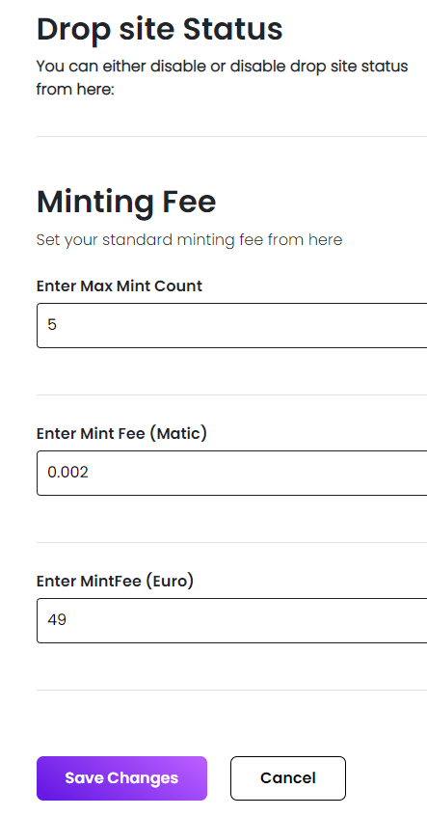

|  |  |  |
| --- | --- | --- |
| Screen | Text (English) | Text (Spanish) |
| Settings | Drop site status | Estado del mint site |
|  | You can either disable or enable drop site status from here: | Puedes activar o desactivar el estado del mint desde aquí: |
|  | Minting fee | Tarifa de minteo |
|  | Set your standard minting fee from here | Establece tu tarifa de minteo desde aquí |
|  | Enter Max Mint Count | Introduce el número máximo de NFTs minteables |
|  | Enter Mint Fee(Matic) | Introduce tu tarifa de minteo (Matic) |
|  | Enter Mint fee (Euro) | Introduce tu tarifa de minteo (Euros) |
|  | Save changes | Guardar cambios |
|  | cancel | Cancelar |
|  | Enter standard max mint count | Introduce minteo estándar. |
|  | Enter standard minting fee | Introduce la tarifa de minteo estándar. |
|  | Loading | Cargando |

We don’t know where these sentences are placed, could you send us screenshot?

**User end**

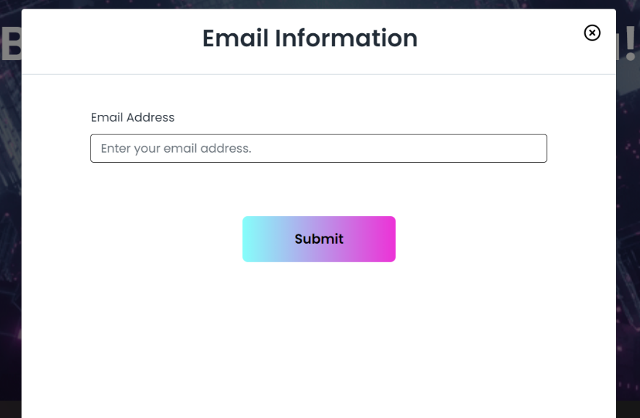

|  |  |  |
| --- | --- | --- |
| Screen | Text (English) | Text (Spanish) |
| NFT-es Drop site | Email information | Detalles de tu email |
|  | Email Address | Email |
|  | Enter your email address | Introduce tu email |
|  | Submit | Enviar |
|  | Enter valid email | Introduce un email válido |

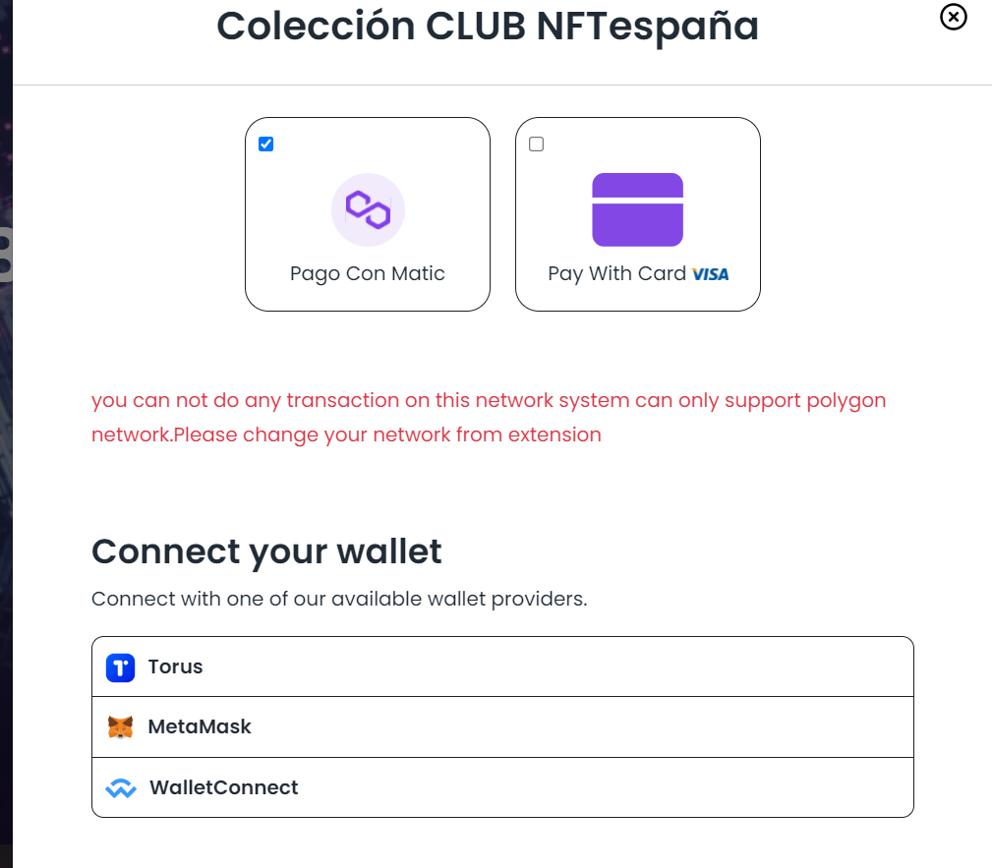

|  |  |  |
| --- | --- | --- |
| Screen | Text (English) | Text (Spanish) |
| NFT-es Drop site | Connect your wallet | Conecta tu wallet |
|  | Connect with one of our available wallet providers | Conecta una de las wallets disponibles. |
|  | You cannot do any transaction on this network system can only support polygon network .Please change your network from extension | No puedes hacer ninguna transacción en esta red, solo soporta red Polygon. Por favor, cambia tu red desde la extensión. |
|  | Torus wallet disconnected successfully | Wallet de Torus desconectada con éxito |
|  | Meta Mask wallet disconnect successfully | Wallet de MetaMask desconectada con éxito |
|  | Login to you account | Inicia sesión |
|  | You have insufficient balance to continue this transactions | No tienes saldo suficiente para realizar esta transacción |
|  | Login to your meta mask account to get your NFT-es | Inicia sesión con una wallet para obtener tu NFT |
|  | Connect your Meta Mask account remotely | Conecta tu wallet en remoto |
|  | Meta Mask account | Cuenta de wallet |
|  | Meta mask address | Dirección de wallet |
|  | Continue to perform this transaction after successful transaction you will receive an email on( test@test.com) | Continúa para realizar esta transacción. |
|  | If you do not have yet installed meta mask extensions you can find on this link | Si no tienes instalada la extension de MetaMask, puedes encontrarla en este enlace |
|  | Waiting for payment | Esperando por el pago |
|  | Creating Payment link | Creando enlace de pago |
|  | Partners | Colaboradores |

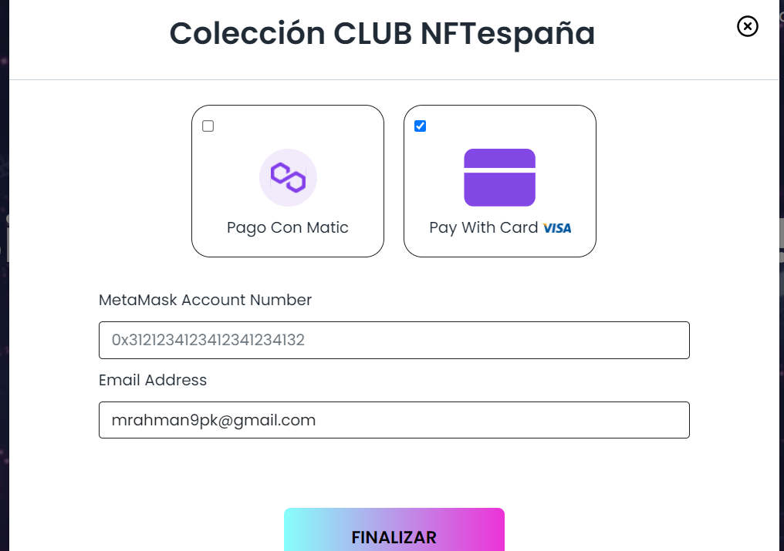

|  |  |  |
| --- | --- | --- |
| Screen | Text (English) | Text (Spanish) |
| NFT-es Drop site | Meta Mask Account number | Número de wallet |
|  | Email Address | Email |
|  | Creating payment link | Creando enlace de pago |
|  | Copy to clipboard | Copiar |
|  | Email is not valid | Email no válido |
|  | Enter valid meta mask address | Introduce una wallet válida |

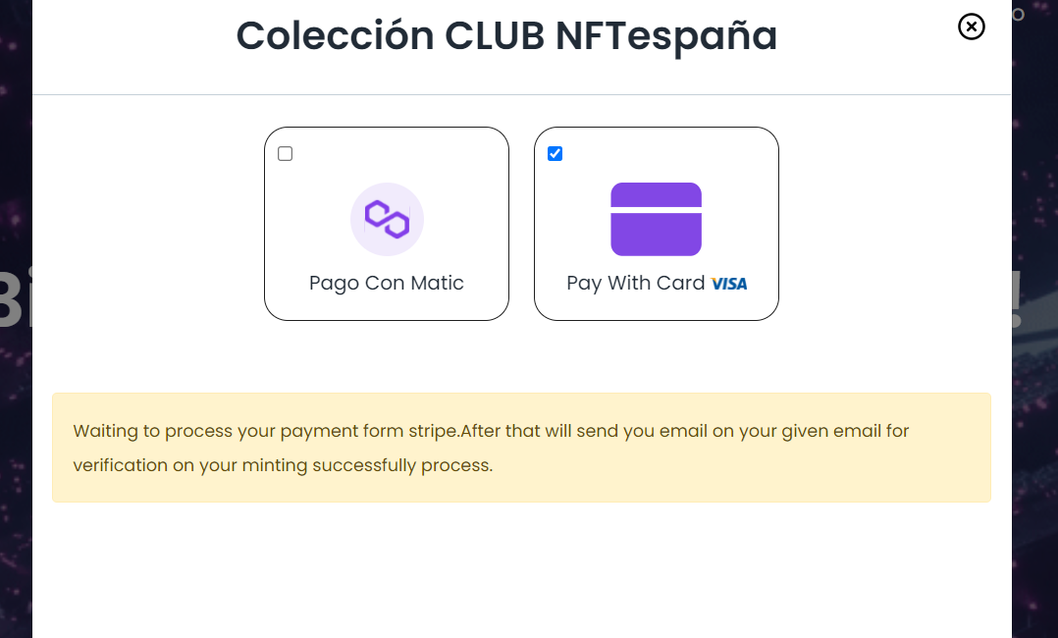

|  |  |  |
| --- | --- | --- |
| Screen | Text (English) | Text (Spanish) |
| NFT-es Drop site | Waiting to process your payment from strip after that will send you email on your given email for verification on your minting successfully process | Espera a que procesemos tu pago. Después te enviaremos un email para verificar tu proceso de minteo. |

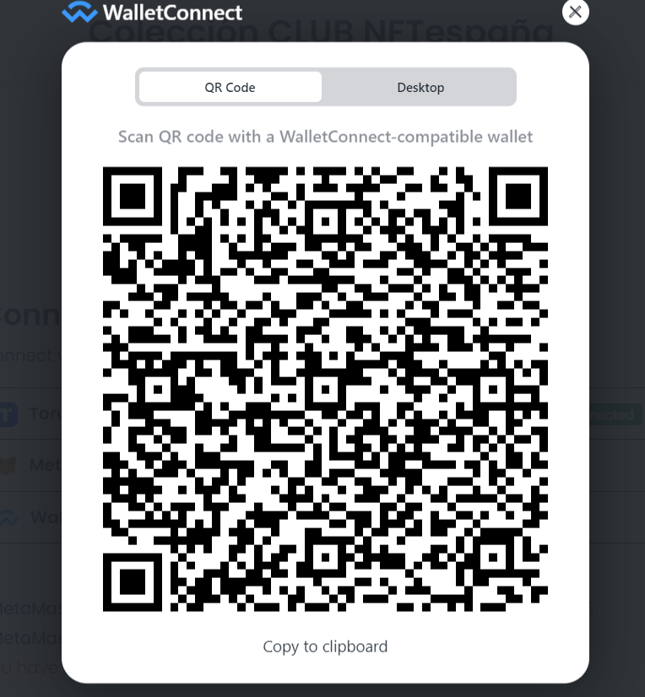

|  |  |  |
| --- | --- | --- |
| Screen | Text (English) | Text (Spanish) |
| Wallet connect QR code scan | QR code | Código QR |
|  | Desktop | Escritorio |
|  | Scan QR code with a wallet Connection -compatible wallet | Escanea el Código QR desde tu wallet compatible |
|  | Copy to clipboard | Copiar |